**Winnipeg School Division Guide Document for Minecraft Education World.**



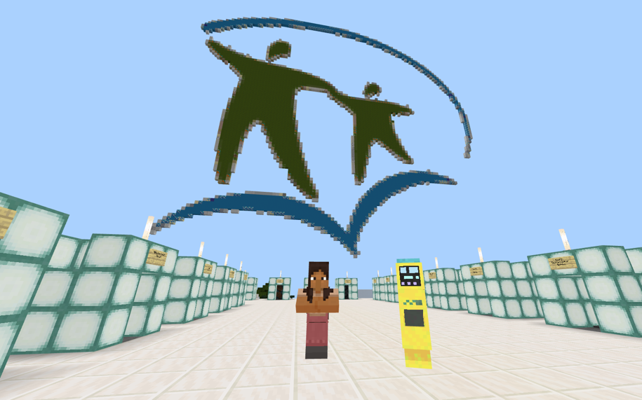

**Table: Coordinates of Program Schools in the Minecraft World**

*To teleport use command /tp ### ### ###*

|  |  |  |  |
| --- | --- | --- | --- |
| **School** | **Minecraft Coordinates** | **School** | **Minecraft Coordinates** |
| WSD Head Offices | -1345 39 -88 | Shaughnessy School | -2292 41 -2881 |
| Wellington School | -342 34 690 | Isaac Newton School | 593 32 -1881 |
| Hugh John MacDonald | 568 31 348 | Rockwood School | --388 29 4922 |
| Meadows West School | -2923 40 -4828 | Brock Corydon School | -1915 21 4756 |
| St. John’s High School | 1696 21 -2233 | Garden Grove | -4015 40 -3640 |
| Elmwood High School | 4565 21 -509 | École Sacré-Coeur | 341 22 409 |
| Inkster School | 1318 31 -3085 | Ralph Brown | 1441 22 -2289 |
| Champlain School | 2111 19 -1975 | Lord Nelson | -672 26 -2598 |
| Luxton School | 2870 21 -2128 | Carpathia | -3052 21 4475 |
| Glenelm School | 3079 19 -1264 | Grant Park | -595 20 5365 |
| River Elm School | 4211 21 -237 | Grosvenor School | -470 26 4100 |
| Daniel McIntyre Collegiate | -690 35 749 | David Livingstone School | 1747 29 -614 |
| Gordon Bell High School | 17 21 2209 | George V | 4942,701,-328 |
| Keewatin Prairie | -2292 96 -1109 | Weston School | -1656 96 -1207 |
| Strathcona | 815 74 -1642 |  |  |

**Bonus School Coordinates**

|  |  |  |  |
| --- | --- | --- | --- |
| **Location** | **Minecraft Coordinates** | **Location** | **Minecraft Coordinates** |
| Mulvey School | -71 33 2878 | Principal Sparling School | -1046 38 191 |
| River Heights School | -1301 29 4568 | John M. King School | -54 32 1331 |
| Kelvin High School | -396 32 3602 | Tech Voc High School | -1405 39 4 |
| General Wolfe School | -746 34 1340 | Robert H. Smith School | -1457 29 4139 |
| Greenway School | -688 23 1865 | Queenston School | -1815 30 3928 |
| Sargent Park School | -1259 37 894 | Clifton School | -1795 39 909 |
| Pinkham School | 192 33 -249 | Dufferin School | 822 31 -17 |
| William Whyte School | 1206 30 -1338 | Ecole Churchill School | 2082 24 4090 |

***MORE LANDMARKS ON NEXT PAGE:***

|  |  |  |  |
| --- | --- | --- | --- |
| **Landmark** | **Minecraft Coordinates** | **Landmark** | **Minecraft Coordinates** |
| Red River Redwood Ave. Crossing | 2392 17 -1198 | Vimy Ridge Park | -431 22 2346 |
| Disraeli Bridge | 2813 17 -362 | Manitoba Hydro | -1604 40 -394 |
| Higgins Rd Loise Bridge | 3344 17 -31 | Pascoe Park | -1664 30 -1028 |
| Seine River Meets Red River | 3641 17 557 | Winnipeg Jets Arena Canada Life Centre | 1242 32 1355 |
| Provencher Bridge | 2438 32 1587 | Sargent Park | -1415 28 631 |
| Assiniboine River Meets Red River | 2324 18 2211 | Winnipeg Sign and CN Stage | 2206 24 1785 |
| Norwood Bridge Red River | 2227 17 2493 | Canadian Museum for Human Rights | 2119 31 1686 |
| **Present Day Arlington Street Bridge** | -85 34 -786 | National Microbiology Lab | 204 35 -272 |
| **Future Arlington Bridge Area** | -85 190 -785 | Kildonan Settlers Bridge NORTH Border | 4440 16 -5060 |
| Harry Lazarenko Bridge | 2393 17 -1200 |  |  |