Meet the Teacher
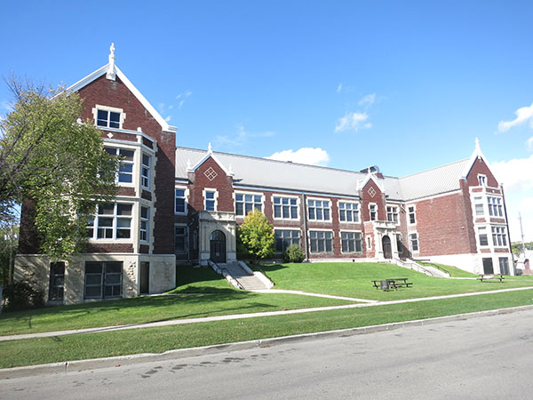
Join us on September 17th, from 3:30-5:50, for a meet-and-greet with the teachers of Isaac Newton!

We will be offering free hot dogs and prizes!

(This is a family event, we ask the students to please attend with a guardian)



