# Register Now

for the Upcoming & Following School Year!

## Little Red Spirit DUFFERIN

# MIS KO MUNE DOUS / MIKO MANITOSIS

Aboriginal Head Start Program

**WHO ARE WE?**

Little Red Spirit Aboriginal Head start is a community based Early Childhood Education program for children between 4-6 and their families.

Little Red Spirit Dufferin

* 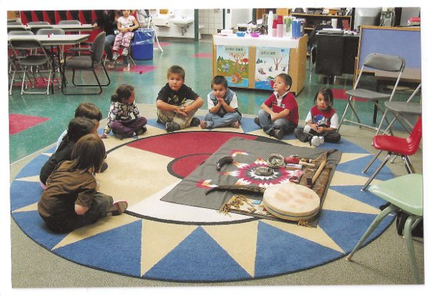is committed to fostering the spiritual, emotional, intellectual, and physical growth of young Aboriginal children living in the Centennial community.’

**WHERE ARE WE?**

Little Red Spirit Dufferin is located in Room 4 at

Dufferin School- Centennial Community

**HOW DO I REGISTER?**

Little Red Spirit Dufferin can be contacted by phone @ 204-770-3382 or by email littleredspiritdufferin@hotmail.com

Little Red Spirit Dufferin runs with the regular school year from September to June.

**545 Alexander Avenue**

**Dufferin School Room 4**

**Winnipeg, Manitoba R3A 0P1**

Monday to Thursday:

AM (8:50 am- 11:30 am)

PM (12:50 pm-3:30 pm)